Introduction to White Box Testing
White-box testing is a method where the internal structure, design, and coding of an item are tested to verify input-output flow and to improve design, usability, and security.
White Box Testing Techniques
- Statement Coverage
Definition: Statement coverage is a white-box testing technique that ensures every single line of source code (statement) is executed at least once during the testing process. It focuses on covering all paths, lines, and statements.
Objective: To calculate the total number of executed statements out of the total statements present in the code.
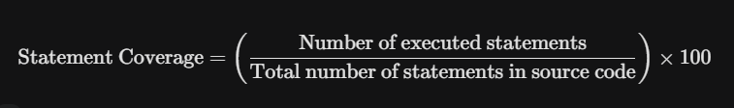
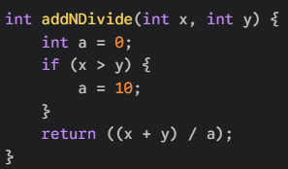
Goal: Achieve 100% statement coverage with minimum test cases.
Test Case 1 (TC1):
- Input: x = 26, y = 17
- Execution Flow: Since 26 > 17, the code enters the if block, sets a = 10, and returns (26+17)/10 = 4.
- Result: All lines are executed. Output is 4.
Limitation of Statement Coverage:
Achieving 100% statement coverage does not guarantee the software is bug-free.
- Issue: In the example above, if we reverse the inputs (y > x), the if block is skipped, leaving a = 0. This causes a division by zero error.
- Conclusion: Statement coverage might miss logical errors that occur in paths not explicitly forced by requirements (e.g., the else case that isn't written)

- Branch Coverage (Decision Coverage)
Definition: Branch coverage measures the percentage of branches (decision points like if-else outcomes) that have been executed. It evaluates how well tests navigate through different possible outcomes of conditional statements.
Objective: To ensure most decision paths are tested, increasing the likelihood of detecting defects.
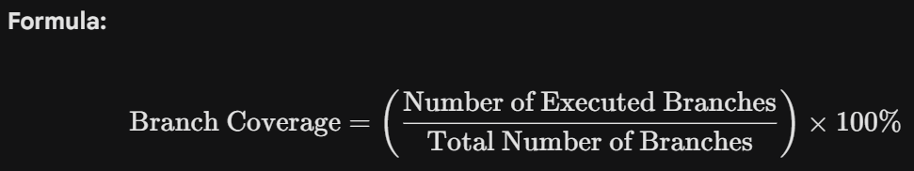
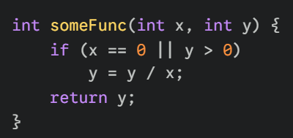
Test Case 1: x=4, y=4 Condition (4==0 || 4>0) is True. Result: 4/4 = 1.
Test Case 2: x=6, y=0 Condition (6==0 || 0>0) is False. Result: Returns 0.
Coverage: These two cases achieve 100% Statement and 100% Branch coverage .
Calculation:
- Executed Branches: 2 (True path by TC1, False path by TC2)
- Total Branches: 2
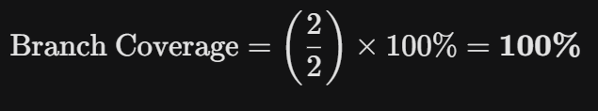
Hidden Defect: If x=0, the system crashes due to division by zero. However, specific combinations in the OR condition might mask this during basic branch testing.
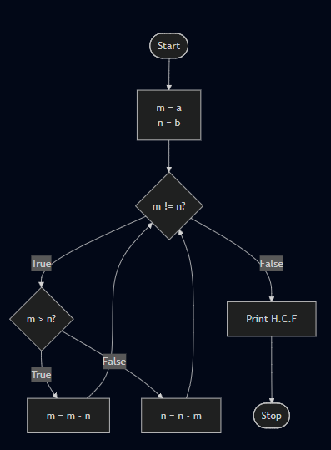
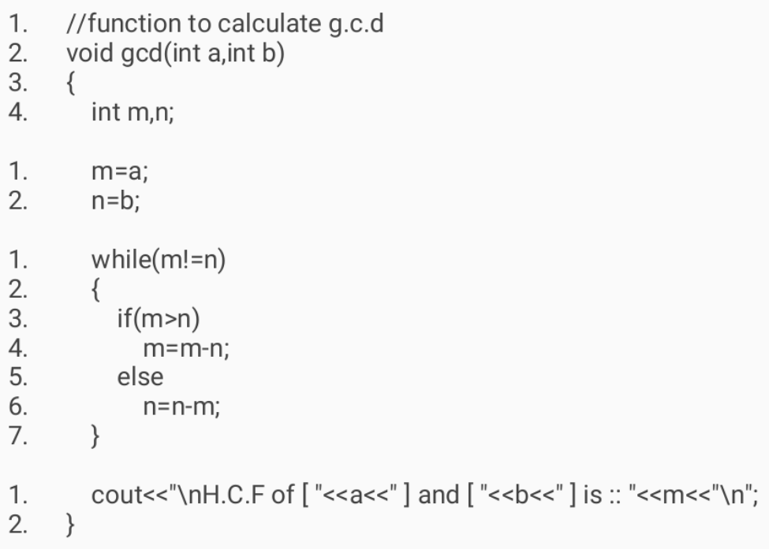
To achieve 100% Branch Coverage, we must ensure that every possible outcome (True/False) from every decision node is executed at least once during testing.
The Decisions:
- while(m != n) has 2 branches: True (Enter loop), False (Exit loop).
- if(m > n) has 2 branches: True (if), False (else).
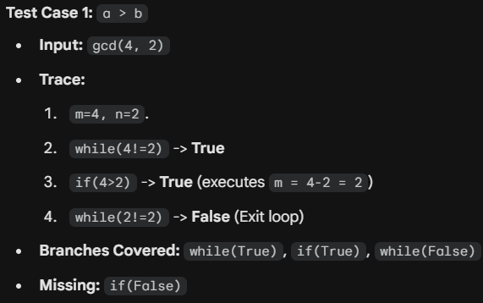
Total Branches to Cover: 4

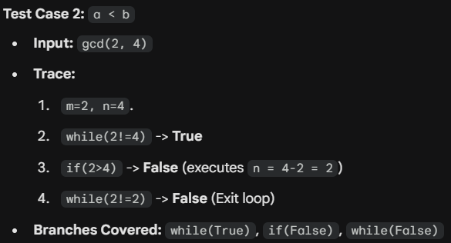

- Condition Coverage
Condition Coverage (also known as Basic Condition Coverage) is a white-box testing metric that focuses on the individual boolean sub-expressions within a decision.
To achieve 100% Condition Coverage, every single atomic condition (the smallest part of a logic statement that is True or False) must be tested as True and False at least once.
In programming, an if statement often contains multiple parts joined by logical operators like AND (&&) or OR (||).
- Decision: The entire statement inside the parenthesis. (A > 5 && B == 0)
- Condition: The individual parts. (A > 5) is one condition; (B == 0) is another.
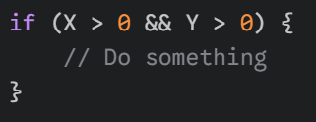
Branch Coverage looks at the final result of the whole if. Condition Coverage looks at the individual pieces inside the if
Here we have two conditions:
- C1: Is X > 0?
- C2: Is Y > 0?

How to achieve 100% Condition Coverage
To get 100% coverage, we need:
- X > 0 to be True at least once.
- X > 0 to be False at least once.
- Y > 0 to be True at least once.
- Y > 0 to be False at least once.
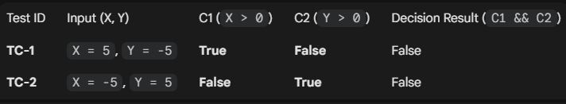 Did we achieve Condition Coverage?
- C1: Was True (TC-1) and False (TC-2). Yes.
- C2: Was False (TC-1) and True (TC-2). Yes.
Result: We have 100% Condition Coverage.

The Trap (Why it can be dangerous)
Look closely at the "Decision Result" column in the table above. In both TC-1 and TC-2, the overall result is False. We never actually entered the if block!
This is the major weakness of Condition Coverage: It does not guarantee Branch (Decision) Coverage. You can test every individual condition effectively but fail to test the scenario where the whole statement is True.
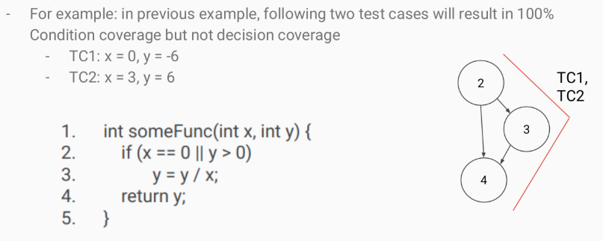

3.2 Decision Coverage:
Decision Condition Coverage (often called Condition/Decision Coverage) is a testing metric that combines the requirements of both Decision (Branch) Coverage and Condition Coverage.
To achieve 100% Decision Condition Coverage, your tests must satisfy two separate goals simultaneously:
- Decision Goal: The entire if statement (the final result) must evaluate to True at least once and False at least once.
- Condition Goal: Every individual atomic condition (e.g., A > 5) inside the if statement must evaluate to True at least once and False at least once.
Why do we need this? (The Problem)
As we discussed, the individual metrics have blind spots:
- Condition Coverage can test all variables but fail to trigger the True branch of the if statement.
- Decision Coverage can trigger both branches but fail to test specific internal variables.
Decision Condition Coverage fixes both blind spots.
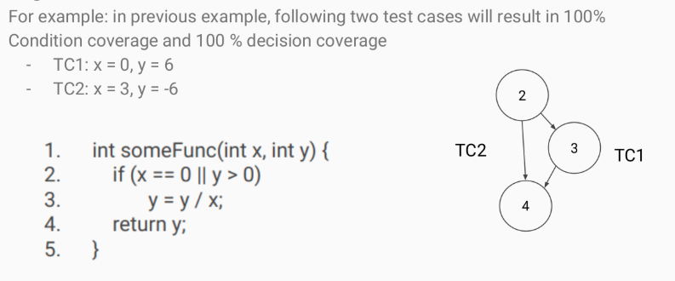
  - Multiple Condition Coverage
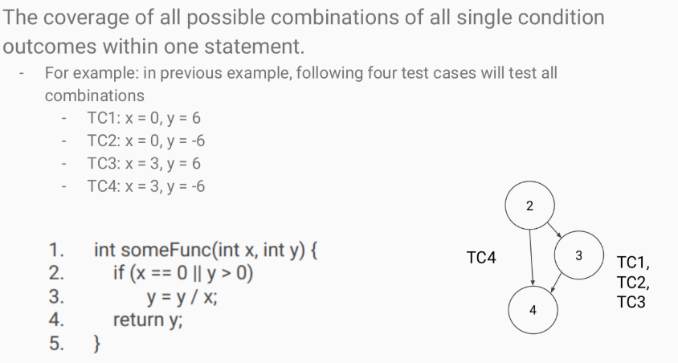
4. Loop Coverage
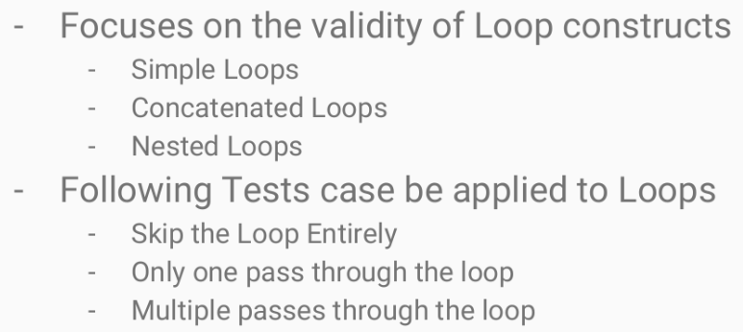
Loop Coverage is a testing metric that focuses specifically on the validity of loop constructs (while, for, do-while). It ensures that a loop behaves correctly regardless of how many times it executes.
Standard Branch Coverage often misses bugs in loops because it only cares about entering the loop (True) and exiting it (False). It doesn't check if the loop fails after running multiple times.
To achieve Loop Coverage, you typically must test three specific scenarios:
1. The "0, 1, Many" Rule
To fully test a loop, you should write test cases that force the loop to execute:
- Zero times: The loop condition is false from the start. (Ensures code works if the loop is skipped).
- One time: The loop runs exactly once and then exits. (Checks basic logic).
- Many times: The loop runs more than once (e.g., 2, 5, or 10 times). (Checks for re-initialization bugs or data accumulation errors).
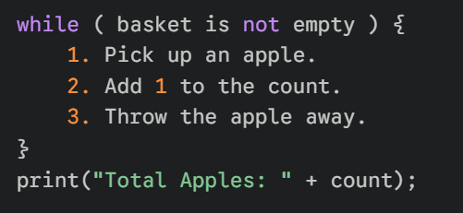
To achieve Loop Coverage, you cannot just test it with a normal basket. You must test three specific scenarios to prove the robot works perfectly.
i) The "Zero" Test (Empty Basket)
- Scenario: You give the robot an empty basket.
- What happens: The robot looks at the basket, sees it is empty, and immediately stops.
- Why test this? You need to make sure the robot doesn't crash or try to pick up air when there is nothing there.
- Loop runs: 0 times.
ii). The "One" Test (Single Apple)
- Scenario: You give the robot a basket with exactly 1 apple.
- What happens: The robot picks up the apple, counts "1", throws it away, checks the basket again (now empty), and stops.
- Why test this? This proves the basic logic works: it can start, do the job once, and stop correctly.
- Loop runs: 1 time.
iii). The "Many" Test (Multiple Apples)
- Scenario: You give the robot a basket with 3 apples (or 5, or 10).
- What happens: The robot repeats the task over and over.
  - Pick, Count, Throw.
  - Pick, Count, Throw.
  - Pick, Count, Throw.
- Why test this? This checks for "memory" problems.
  - Example Bug: Does the robot forget the count after the first apple? Does it get tired and stop after the second one?
- Loop runs: >1 times.
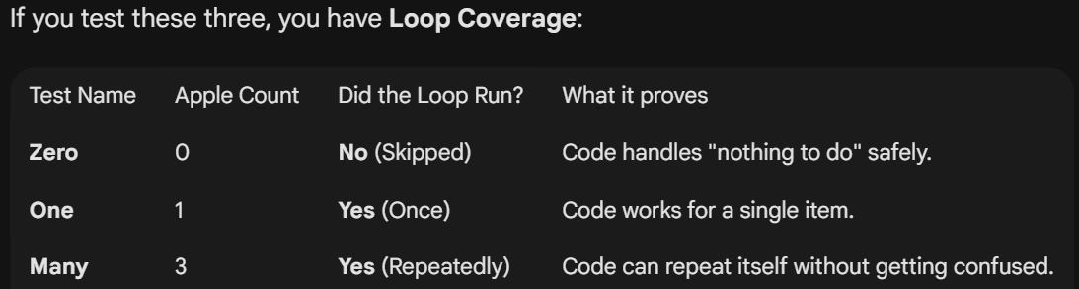
Cyclomatic Complexity
Cyclomatic Complexity is a software metric used to indicate the complexity of a program. It essentially counts the number of "independent paths" through your code.
M = E - N + 2P
Where:
- M = Cyclomatic Complexity.
- E = Number of Edges (arrows/lines) in the Control Flow Graph.
- N = Number of Nodes (circles/boxes) in the Control Flow Graph.
- P = Number of Connected Components (usually 1 for a single program/function)
What does the Result Mean?
The number you get tells you two things:
- Complexity: Higher number = more complex code (harder to maintain).
- Testing Effort: The number M is the minimum number of test cases you need to achieve complete Branch Coverage (Basis Path Testing).
- 1-10: Low complexity (Good code).
- 10-20: Moderate complexity (Risk).
- 20-50: High complexity (High risk, refactor needed).
- >50: Untestable (Rewrite required).
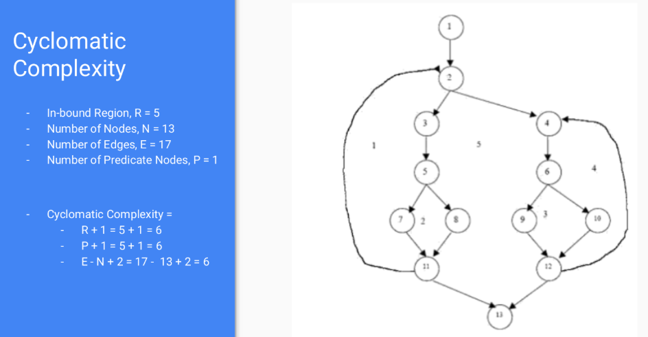
How to Identify if P is one or many?
- Draw your graph.
- Take a pencil. Put it on the Start node.
- Trace lines. Can you reach every other node in your drawing just by following the arrows?
  - Yes: It is one component. P = 1.
  - No: If you have to lift your pencil and move it to a different "Start" node to draw the rest of the system, then you have multiple components. P = Number of times you lift your pencil.

2 shortcut Formulas:
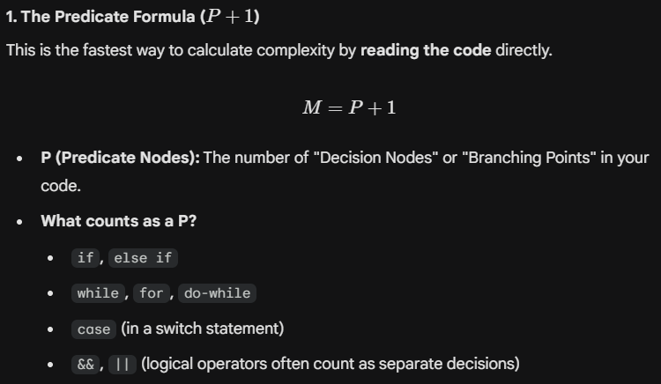
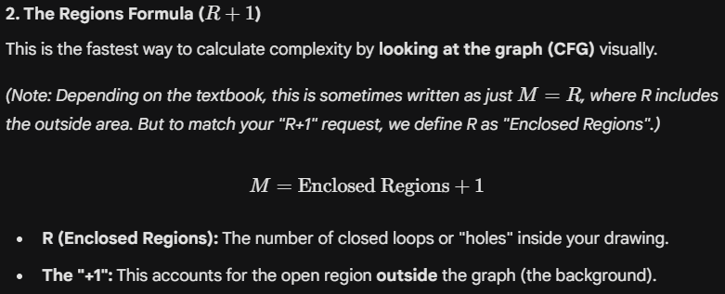

5. Basis Path Testing
Basis Path Testing is a structured testing technique that helps you identify the minimum number of test cases needed to execute every part of a function at least once.
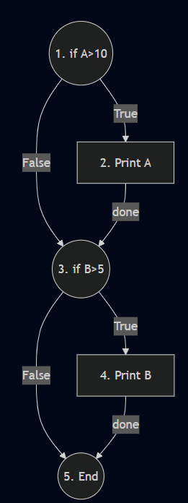
It relies on Cyclomatic Complexity to tell you exactly how many independent paths exist in your code. If you test all these "Basis Paths," you are guaranteed to achieve 100% Branch Coverage.
1. The Core Steps
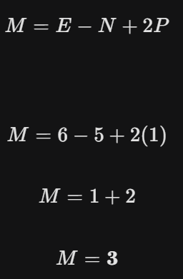
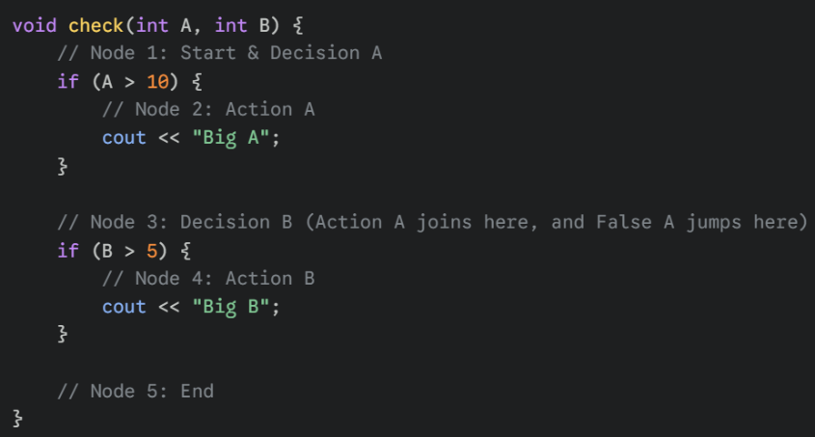
To perform Basis Path Testing, you follow these three steps:
a) Draw the Control Flow Graph (CFG): Visualize the code as nodes and arrows.
b) Calculate Cyclomatic Complexity
c) Identify the Independent Paths: Find the specific routes through the graph that satisfy that number.
Result: The Cyclomatic Complexity is 3. This means we need 3 Independent Paths to fully test this code's structure (Basis Path Coverage).
